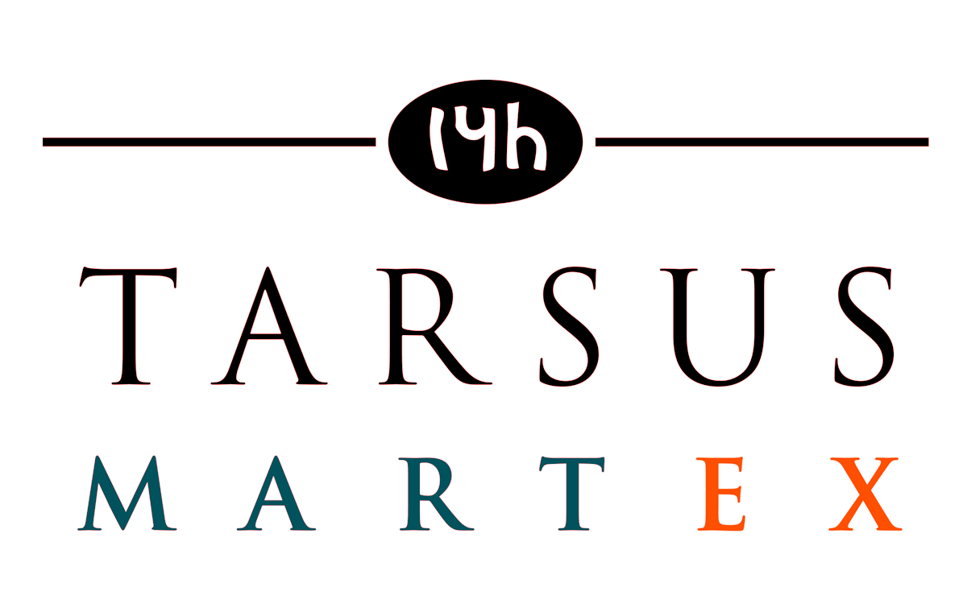

Credit Card Information Form
2018 Label Expo Americas Booth Insurance

Company Name_______________________________

Name on Card_________________________________

Card Number__________________________________

Card Type MasterCard / VISA / Amex

Amount_______________________________________

Expiration Date________________________________

Card Billing Address____________________________

______________________________________________

Telephone Number _____________________________

Signature______________________________________

Booth #_______________________________________

*Charges will appear on statement as Tarsus-Labelexpo

*A 3% fee will be added to all Credit card transaction totals

Please either fax this form to: (262) 782-2469 Attn: Lori Mork

Or email to: Lmork@tarsus.com

